**DAILY ONLINE ACTIVITIES SUMMARY**

|  |  |  |  |  |  |  |  |  |
| --- | --- | --- | --- | --- | --- | --- | --- | --- |
| **Date:** | **23-6-2020** | | | | | **Name:** | **Prajna** | |
| **Sem & Sec** | **8th sem ‘B’** | | | | | **USN:** | **4AL16CS067** | |
| **Online Test Summary** | | | | | | | | |
| **Subject** | | **-** | | | | | | |
| **Max. Marks** | | **-** | | **Score** | | | **-** | |
| **Certification Course Summary** | | | | | | | | |
| **Course** | **Introduction to CSS** | | | | | | | |
| **Certificate Provider** | | | **Great learning** | | **Duration** | | | **5hrs** |
| **Coding Challenges** | | | | | | | | |
| **Problem Statement:**1**.** Write a python program to split list based on first character of word. | | | | | | | | |
| **Status: Completed** | | | | | | | | |
| **Uploaded the report in GitHub**  **GitHub link:** | | | | | **Yes**  **https://github.com/alvas-education-foundation/prajna_k** | | | |
| **If yes Repository name** | | | | | **prajna_k** | | | |
| **Uploaded the report in slack** | | | | | **yes** | | | |

Online Test Details: (Attach the snapshot and briefly write the report for the same)

Certification Course Details: (Attach the snapshot and briefly write the report for the same)

Coding Challenges Details: (Attach the snapshot and briefly write the report for the same)

2) certification course

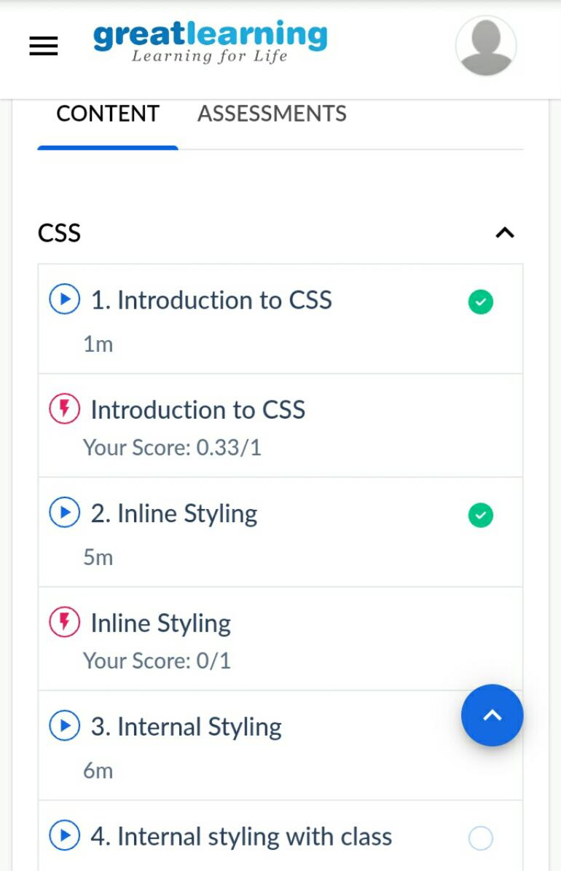

3) coding challenges

from itertools import groupby

from operator import itemgetter

word_list = ['be','have','do','say','get','make','go','know','take','see','come','think',

'look','want','give','use','find','tell','ask','work','seem','feel','leave','call']

for letter, words in groupby(sorted(word_list), key=itemgetter(0)):

print(letter)

for word in words:

print(word)

|  |
| --- |
|  |
|  |  |
|  |  |
|  |  |
|  |  |
|  |  |